CS 482 Homework 1 Talha Agcayazi

All code are in the Appendix.
Input Images:
Test.jpg:
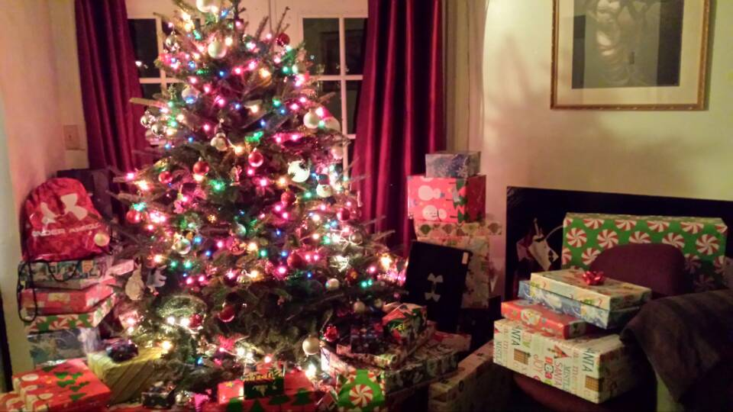
Frogdefrog2.png:
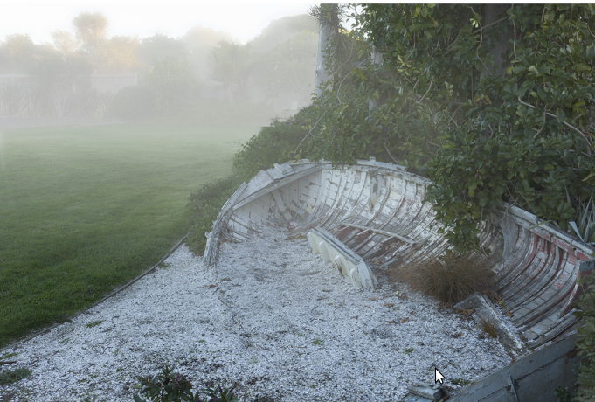
Matlab Output:
Normal Image:
Grey Scale Image:
Normalized Greyscale image:
Red Hist:
Green Hist:
Blue Histogram:
Greyscale Histogram:
Normalized Grayscale Histogram:
Binary Image:
Normal Foggy Image:
Only Gamma correlation:
This image seems better without normalization.
Normalized Dehazed image:
The fog seems like it is almost completely gone but I don’t know why I got dark effects.
Appendix
OpenCV (Python)
# (b) write and run code that {gets RGB (see attached or choose another RGB) image and display / print the image,
# transform the RGB image to gray scale, find out the mean and variance for both RGB and gray-scale images,
# normalize the gray-scale image using min and max gray values(e.g., range), calculate, display, and
# print the histogram for both RGB and gray value images}, and transform the gray level image to a binary image}
# (c) Computational Photography (using D01-slide 23 <original vs. fog added>: (c1) using Matlab; and (c2)using OpenCV
# find the best mix of gamma correction and histogram equalization to defog images. Towards that end define some
# measure of image quality (e.g., high frequency contents) to seek for best image quality.

import cv2
import numpy as np
from matplotlib import pyplot as plt

#load image
img = cv2.imread('test.jpg')

#show original Image and pring mean + variance
#cv2.imshow('Original Image', img)
print 'Original Image mean:', img.mean()
print 'Original Image varianca:', img.var()

#transform the image into Greyscale and show image, print mean + variance
grayImg = cv2.cvtColor(img, cv2.COLOR_BGR2GRAY)
#cv2.imshow('Greyscale Image', grayImg)
print 'Grayscale Image mean:', grayImg.mean()
print 'Grayscale Image varianca:', grayImg.var()

#Normalize the image histogram
normImg = cv2.equalizeHist(grayImg)
#cv2.imshow('Normalized Greyscale Image', normImg)
histNormImg = cv2.calcHist([normImg],[0], None, [256], [0,256])
plt.plot(histNormImg)
plt.xlabel('Normalized Greyscale Image Histogram')
#plt.show()

#calculate and view RGB histogram
Red = img[:,:,2]
Green = img[:,:,1]
Blue = img[:,:,0]

histImg = cv2.calcHist([Red],[0], None, [256], [0,256])
plt.plot(histImg, 'r')
plt.xlabel('RGB histogram')

histImg = cv2.calcHist([Green],[0], None, [256], [0,256])
plt.plot(histImg, 'g')

histImg = cv2.calcHist([Blue],[0], None, [256], [0,256])
plt.plot(histImg, 'b')
# plt.show()

#calculate and view grayScale histogram
histGrayImg = cv2.calcHist([grayImg],[0], None, [256], [0,256])
plt.plot(histGrayImg)
plt.xlabel('Grayscale histogram')
#plt.show()

#Graylevel to binary
binaryImg = cv2.inRange(grayImg,np.array(128), np.array(255) )
#cv2.imshow('Binary Image', binaryImg)

#Computational Photography:

#load image
fogImg = cv2.imread('frogdefrog2.png')
cv2.imshow('Foggy Image', fogImg)
degammaFogImg = np.divide((fogImg),255.0)
degammaFogImg = np.multiply(degammaFogImg, 255)
degammaFogImg = np.power(degammaFogImg,(1/0.3))
cv2.imshow('dehaze Image', degammaFogImg)

cv2.waitKey(0)
cv2.destroyAllWindows()

Matlab
% (b) write and run code that {gets RGB (see attached or choose another RGB) image and display / print the image,
% transform the RGB image to gray scale, find out the mean and variance for both RGB and gray-scale images,
% normalize the gray-scale image using min and max gray values(e.g., range), calculate, display, and
% print the histogram for both RGB and gray value images}, and transform the gray level image to a binary image}
% (c) Computational Photography (using D01-slide 23 <original vs. fog added>: (c1) using Matlab; and (c2)using OpenCV
% find the best mix of gamma correction and histogram equalization to defog images. Towards that end define some
% measure of image quality (e.g., high frequency contents) to seek for best image quality.

img = imread('test.jpg');

%show original Image and pring mean + variance
figure();
imshow(img);
title(['Original Image'])
xlabel(['x pixels'])
ylabel(['y pixels'])
disp('Original Image mean');
muImg = mean(img(:))
disp('Original Image variance');
varImg = var(double(img(:)))

%transform the image into Greyscale and show image, print mean + variance
figure();
grayImg = rgb2gray(img);
imshow(grayImg);
title(['Greyscale Image'])
xlabel(['x pixels'])
ylabel(['y pixels'])
disp('Greyscale Image mean');
muGrayImg = mean(grayImg(:))
disp('Greyscale Image variance');
varGrayImg = var(double(grayImg(:)))

%Normalize the image histogram
figure();
normGrayImg = (double(grayImg) - muGrayImg)./sqrt(varGrayImg);
imshow(normGrayImg);
title(['Normalized Greyscale Image'])
xlabel(['x pixels'])
ylabel(['y pixels'])
disp('Normalized Greyscale Image mean');
muNormImg = mean(normGrayImg(:))
disp('Normalized Greyscale Image variance');
varNormImg = var(double(normGrayImg(:)))

%calculate and view RGB histogram
figure()
imhist(img(:,:,1)) %R
title(['Red Histogram'])
figure()
imhist(img(:,:,2)) %G
title(['Green Histogram'])
figure()
imhist(img(:,:,3)) %B
title(['Blue Histogram'])

%calculate and view Grayscale histogram
figure()
imhist(grayImg(:))
title(['Grayscale Histogram'])

%calculate and view Normalized Grayscale histogram
figure()
imhist(normGrayImg(:))
title(['Normalized Grayscale Histogram'])

%Graylevel to binary
figure();
binaryImg = im2bw(grayImg, 0.5);
imshow(binaryImg)
title(['Binary Image'])
xlabel(['x pixels'])
ylabel(['y pixels'])

%% Computational Photography.
figure()
fogImg = imread('frogdefrog2.png');
imshow(fogImg);
title(['Frog Image'])
xlabel(['x pixels'])
ylabel(['y pixels'])

% gamma correction
figure()
degammaFogImg = uint8(255.*(double(fogImg)./255.0).^(1/0.2));
imshow(degammaFogImg); %+25 here works a little bettwer
title(['de gamma Image'])
xlabel(['x pixels'])
ylabel(['y pixels'])

% Trying to normalize the image
figure()
degammaFogImg = double(degammaFogImg);
redImg = degammaFogImg(:,:,1);
greenImg = degammaFogImg(:,:,2);
blueImg = degammaFogImg(:,:,3);

k = 3;

muRedImg = mean(redImg(:))
varRedImg = var(redImg(:))
normRedImg = (redImg - muRedImg)./sqrt(varRedImg*k);

muGreenImg = mean(greenImg(:))
varGreenImg = var(greenImg(:))
normGreenImg = (greenImg - muGreenImg)./sqrt(varGreenImg*k);

muBlueImg = mean(blueImg(:))
varBlueImg = var(blueImg(:))
normBlueImg = (blueImg - muBlueImg)./sqrt(varBlueImg*k);

dehazedImg = degammaFogImg;
dehazedImg(:,:,1) = normRedImg;
dehazedImg(:,:,2) = normGreenImg;
dehazedImg(:,:,3) = normBlueImg;

imshow(dehazedImg);
title(['dehazed Image'])
xlabel(['x pixels'])
ylabel(['y pixels'])

